**A CRM APPLICATION FOR WHOLESALE RICE MILL**

**1. Project Overview**

This project focuses on building a **CRM application using Salesforce** to streamline and optimize sales, inventory, and supplier management for a wholesale rice mill. By leveraging Salesforce's standard and custom features, the project aims to track daily rice production, monitor sales, and deliver detailed reports to stakeholders. The application is designed to enhance **data accuracy**, **operational efficiency**, and **decision-making** for the rice mill's management team.

**2. Objectives**

**Business Goals:**

* Provide a centralized system for managing rice production, sales, and inventory.
* Automate daily reporting to help owners make data-driven decisions.
* Simplify communication between suppliers, employers, and workers.

**Specific Outcomes:**

* Implementation of **custom objects** to track rice details, sales, suppliers, and consumers.
* Creation of **reports and dashboards** to analyze sales trends and stock levels.
* Development of validation rules to ensure data quality and security.

**3. Salesforce Key Features and Concepts Utilized**

1. **Custom Objects:**
   * **Rice Stock:** Tracks rice types, quantity available, and price per kg.
   * **Daily Sales:** Tracks daily transactions, including rice type, quantity sold, and total revenue.
   * **Suppliers and Consumers:** Manages suppliers’ contributions and consumer data.
2. **Relationships:**
   * **Master-Detail Relationship** between **Rice Stock** and **Daily Sales** for roll-up summary fields.
   * **Lookup Relationships** between suppliers and rice stock for supply tracking.
3. **Formula and Roll-Up Summary Fields:**
   * Formula Field to calculate **Total Sales Amount**:  
     Total Sale Amount = Quantity Sold * Price/kg.
   * Roll-Up Summary Field to summarize rice distributed by suppliers.
4. **Validation Rules:**
   * Example: Prevent users from saving a sale record where the quantity sold exceeds available stock.
   * Quantity_Sold__c > Rice_Stock__r.Quantity_Available__c
5. **Reports and Dashboards:**
   * Daily rice sales summary report.
   * Revenue trends and inventory analysis dashboards.
6. **Permission Sets and Roles:**
   * Owner: Full access to all objects and records.
   * Employer: Limited access to manage sales and workers.
   * Worker: Restricted access for task-specific operations.

**4. Detailed Steps to Solution Design**

**A. Objects and Fields:**

* **Rice Stock:**
  + Fields: *Type of Rice, Quantity Available, Price/kg, Production Date.*
* **Daily Sales:**
  + Fields: *Rice Type (Lookup to Rice Stock), Quantity Sold, Total Sales Amount (Formula), Sale Date.*
* **Suppliers:**
  + Fields: *Supplier Name, Supplied Quantity, Contact Details.*

**B. Validation and Formula Rules:**

* Validation for empty phone or email fields:
* OR(ISBLANK(Phone_Number__c), ISBLANK(Email__c))
* Formula for cross-object calculation:
* Amount Paid = Rice_Taken_by_Shops__c * Rice_Mill_Name__r.Rice_Price_kg__c

**C. User Interface:**

* Page layouts customized for owners, employers, and workers.
* Lightning components for visual data representation.

**D. Reporting:**

* Reports generated using custom report types, such as **Rice Mill with Consumers**.
* Fields included: *Consumer Name, Rice Type, Price/kg, Mode of Payment, Amount Paid*.

**5. Testing and Validation**

**Unit Testing:**

* Apex Classes and Triggers tested for functionality:

          Trigger to send email notifications to consumers upon record creation.

**User Interface Testing:**

* Ensured seamless navigation and accuracy in data presentation.
* Verified validation rules and formula calculations.

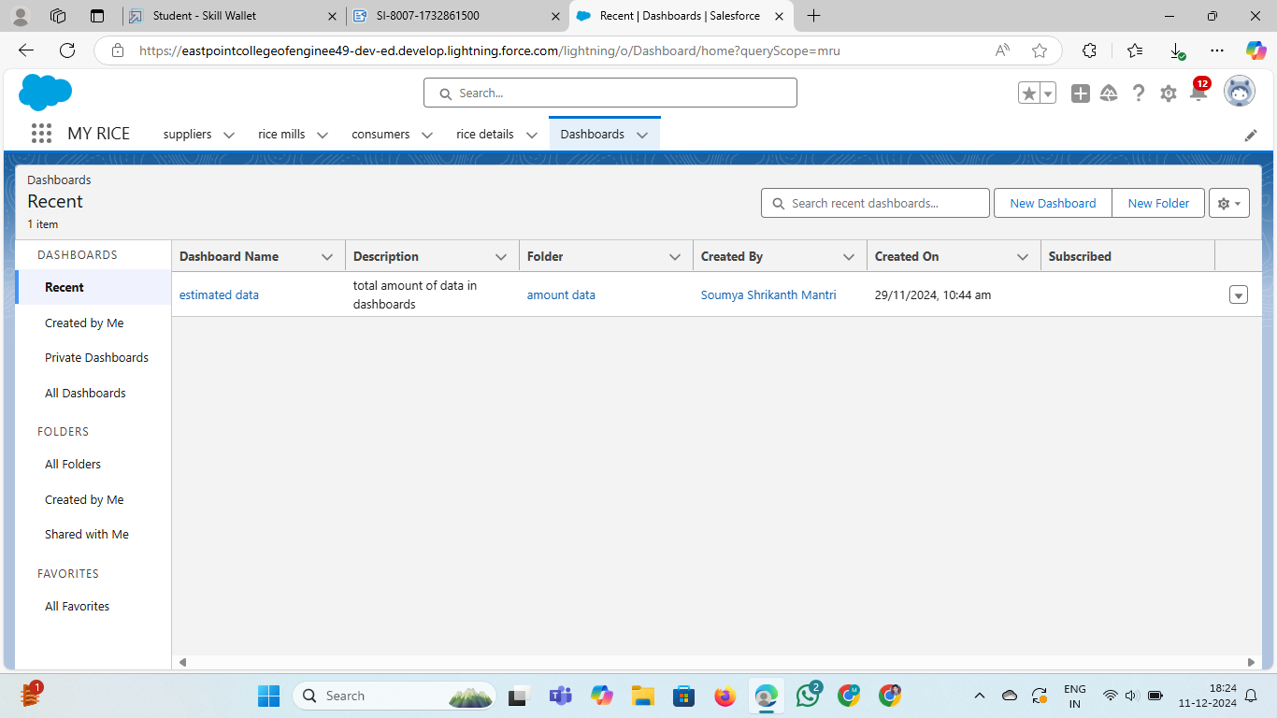

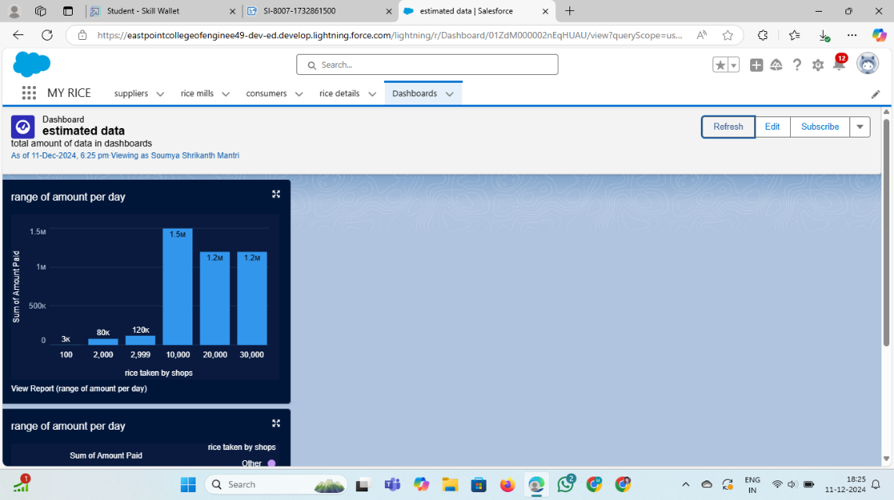

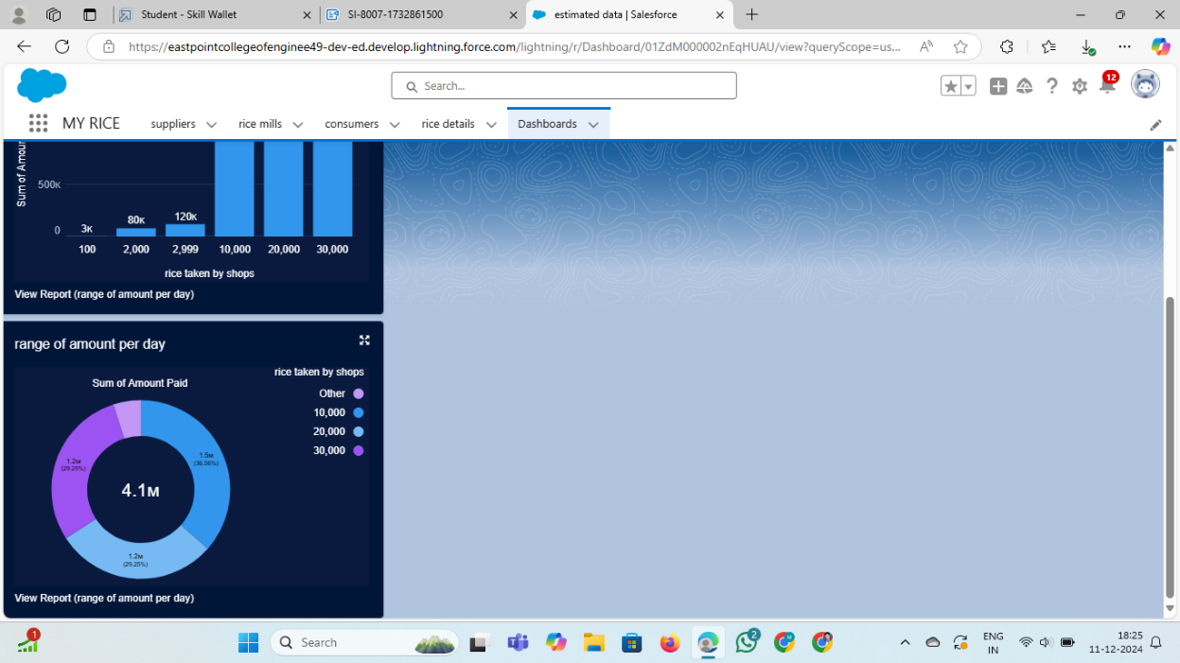**6. Key Scenarios Addressed by Salesforce in the Implementation**

**Scenario 1: Daily Sales Tracking**

Sales data is automatically recorded and linked to inventory updates.

**Scenario 2: Inventory Management**

Owners can view real-time updates on available stock and identify shortages.

**Scenario 3: Supplier Analysis**

Suppliers’ contributions to the rice stock are tracked and summarized.

**Scenario 4: Revenue Reports**

Revenue generated by rice type and time period is visualized in reports and dashboards.

**Scenario 5: Role-Based Access Control**

Different levels of access ensure data security and functionality for various roles.

**7. Conclusion**

**Summary of Achievements:**

* Developed a CRM application tailored to the rice mill's operational needs.
* Automated daily sales tracking and reporting.
* Implemented robust data validation to ensure accuracy.
* Delivered a scalable and efficient system that enhances decision-making for stakeholders.